Project Report 1

Information Gathering for a Ski Hill App

Written by: Woo Jae Lee, Brian Nguyan, and Cody Fulford

University of Calgary

CPSC 481 – Human Computer Interaction

# Introduction:

For our project, we are designing and implementing a phone application that will assist skiers and snowboarders both on the hill and off the hill. The main use of our system will be used when the users are trying to decide which resort that they should go to. The app would gather any relevant information about any resorts that the user specifies and consolidate them into our app where the user would be able to review all the data in a side-by-side comparison. Our application would also be able to be used while on the resort. The app will provide information to the user about the current conditions of runs, lift wait times, and the wait times of the various eating establishments at the resort. This information will be supplied by other users of the system. These users consist of the already mentioned skiers/snowboarders, the ski patrol at the resort, the resort/eating establishment employees, and travel agents.

# Stakeholders:

This application will have many stakeholders from a variety of professions and therefore we will need to consider their various needs for the design. The primary stakeholders that we will target are the people who are visiting the ski resorts for leisure. This is because this is the largest of the stakeholder groups. We chose to provide best for the largest group because they will be able to provide us the most feedback through our survey, there is a very diverse set of skills and perspectives across them, and should we market the app, we would like to market to the largest audience.

The second group of stakeholders that we would like to target is the ski patrol. This is because this is a group that will be in communication with all the other groups and have a vested interest in knowing about the ski hill. Since the ski patrol are always very knowledgeable about the hill that they are patrolling at, we recognize that their needs for an app are very different than those of the leisure skier. Ideally, we would include a feature in our app that would allow a leisure skier to alert the ski patrol to the location of an injured person or a hazard on a run. This would benefit all stakeholders in this app since the safety of the skier is of the highest priority.

The third group of stakeholders that we are going to work to provide for are the owners of the resorts. We would provide for the resorts themselves by allowing the resorts to show the wait times for their various eating establishments and chair lifts. We would also gather information on the hotels and other such places in the area to inform a leisure skier about where they can stay, as well as distance to the hill. These wait times would need to be updated either by the users or by the personnel at the various lifts and eating establishments.

The fourth and final group that we would be providing for are travel agents. The only feature that would need to be implemented beyond what we have already set out to do to accommodate them would be the ability to track several (hundreds) of resorts all at the same time so that the agent can easily check the status of all possible resorts for their client and make an informed decision while needing to put in far less work than they would have needed to if they needed to check all places manually.

# Research Methods:

## Method 1:

The first method that we chose to use is to survey potential users. We created a survey on SurveyMonkey and distributed it to friends, family, other skiers that we know, and on skiing forums across the internet. We felt that this would be a good research method because it required relatively little effort by us to gather results and we could reach a large and diverse audience very quickly. Also, since the ski/snowboard season has not fully started yet, we felt that it would be a large waste of our time to go to a resort and survey potential users in person. Therefore, we decided to create an online survey, because even though the resorts are quiet, the online forums are quite busy with people excited to hit the slopes. However, we may do live surveys at resorts in the future when the resorts have more active users.

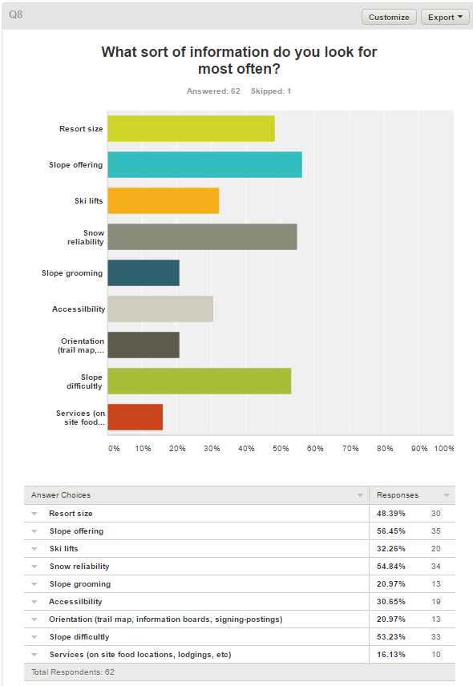 We have allowed our survey to remain active as long as possible. The aim of our survey was to learn more about those who ski, the average ability of the skier, and to gather information on the main kind of information that a skier looks for when deciding when and where to go skiing. We managed to survey a total of 63 people. We recognize that this is a very limited survey and that to get better results we would need to survey many more people. The results show that most skiers rank themselves as expert, and mostly ski in areas nearby. Since the skiers like to ski without much travel, this means that the skiers will often have at least 1 resort that they visit much more than others, promoting the use of a favorites menu so that a user can quickly access information about a specific resort without needing to search for it. The results also showed that a surprising amount (~27%) of skiers rent their gear. This suggests that having the ability to search for nearby rental locations is a feature to consider adding. The results show that the most common method for people to learn about results is through word of mouth (~73%) and through the resort website (~65%). This means that we should consider a system that allows users to give ratings for the resorts and possibly leave comments. This would consolidate the aspects of both methods into a single locate, making it very easy for the user. We also asked people what information is most important to them when choosing a ski resort to visit. You can see the results of this question to the right. This is perhaps the most important question that we asked as it will heavily influence the design of our final product in regards to what sort of information is important to show immediately and what information the user can access after looking at the resorts individual page. The final important question that we asked was if our users use a currently available application while they are on the slopes. The results showed that ~30% of people use a skiing application while they are skiing. We hope to change this by designing our system so that it can provide features that skiers can use on the hill and designing them such that a user can use them easily on the hill.

## Method 2 (Android):

The second IDEO method that we used for research is the Competitive Product Survey. What we have done is we have looked at other apps on both the Apple store as well as the Google store and have investigated what features of these products worked well and what features did not work well. The apps that I looked at from the google store are “OnTheSnow”, “SkiResort.info”, and “Open Snow Ski Forecasts”. Out of these 3 different apps, the one that I found to be the best to be OnTheSnow.

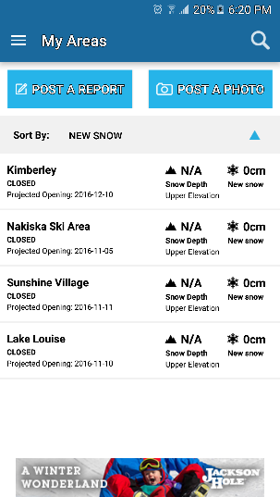OnTheSnow has access to skiing websites across the world and lets you create a list of favorites. Your list of favorites will display information as a small tab and tapping on that tab opens more information about the ski hill such as location and weather forecasts. This is the best of the 3 because the important information of current snowfall is displayed on the small tab for easy access. If you tap on a resort it will take you to a page with more information about the resort. The first information that you see when you go to a resorts individual page is information on the current snowpack, the weather forecasts, and past snowfall. This app also offers to send you a notification about large snowfalls at your favorite resorts. This option can be easily toggled for each of your favorite resorts. The issues with this app is that it works very slowly. So even though it provides a good amount of information about the ski resorts, it is a bit clunky to use. Also, since the app is continuously checking for updated ski conditions for the resorts that you would like to be notified about a large snowfall, the app is constantly using data which can be a problem for some users.

SkiResort.info is the second-best app that I could find for free on the app store because it shares many of the same abilities with OnTheSnow, but it has a far worse user interface. The features that it shares with OnTheSnow are the ability to find ski resorts form all over the world and create a list of favorite resorts so that you can quickly find information about them. This app is missing a few key features and design choices that make the OnTheSnow app that much better to use. The first design choice that makes this app worse is that on the favorites menu, they do not display the amount of snow that has fallen that day. This means that to compare the ski hills to each other you need to go to their individual pages inside the app and remember the current snow fall instead of looking at a single list. What makes this problem even worse is the second bad design decision that they made. When you open a resorts individual page inside the app, the information about current and past snowfall is not on the opening page. Instead it is tabs that you can then touch that will take you to pages describing the resort, but none will take you to the current conditions which is what a skier cares the most about. To find information on the current snow conditions, a user needs to swipe left three times, and to get information about the weather forecast, the user needs to swipe once more past the snow fall conditions. It took me a few seconds to figure out that I could swipe because the image of the skier in the background obscures the small dots at the bottom of the page that indicate what page you are on.

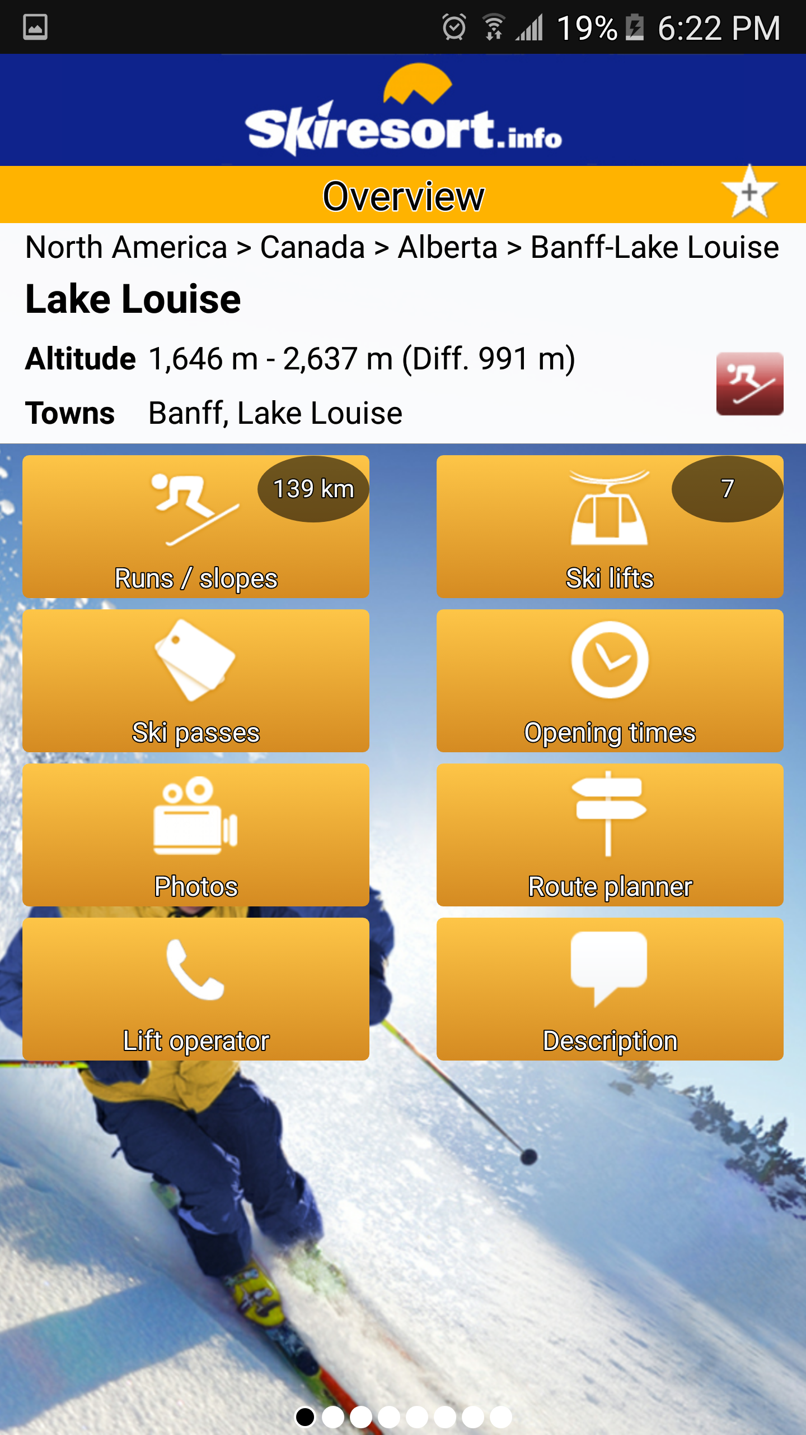

By far, the worst of the 3 different apps is the Open Snow Ski Forecasts app. This app does have the features that the others have where you can create favorites and view information about the individual ski hills. However, to save any favorites a user needs to create an account with the application. This is not a personalized account stored locally for the app so that one device can have multiple users (though that would still be a pointless design decision in my opinion), but an account with the company. The major problem with this is that it removes any sort of pick-and-play functionality for the app. It also made me immediately wonder why I needed to be giving them my email address and ultimately decided to not create an account to avoid the spam that I am sure to be getting. There is also no quick access to your favorite resorts, access to your list of favorites can be found under the settings tab, which I only found while I was exploring the app. Until then, I had assumed that the favorites tab would only appear when you created an account. This app will also send a notification to you every time you start the app if you have not given it permission to view your location always. While the other apps do ask for your location, they only ask for it during first-time startup. If you deny them access, the other apps will accept this and will stop asking for access. Overall, I find that this app is not very user friendly and is more concerned with gathering information about you than giving you the information that you want.

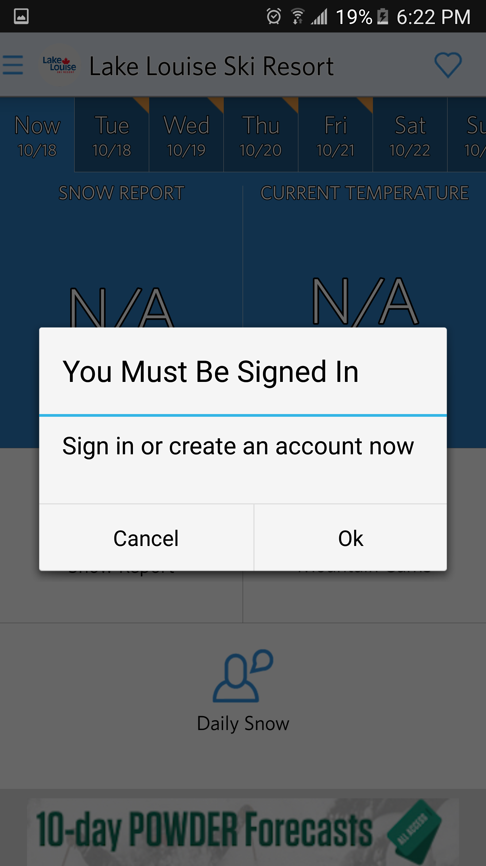

## Method 2 (iPhone):

We could find 2 iPhone apps that looked promising and appeared to be attempting to have the same functionality that we are looking to have. The two apps that we found are named “Trail Talk” and “Obertauern”.

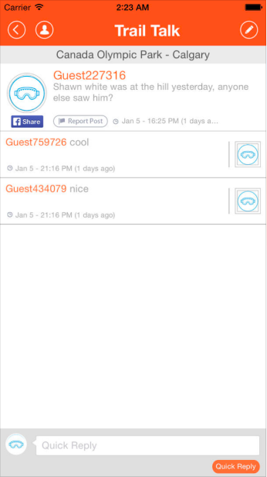The first iPhone app that we looked at is called “Trail Talk”. It is kind of a SNS app using in Canada ski-hill for making friends at the hill. Users can join anonymously, and interact with others during skiing. There are three different things that this app has done differently that make it stand out from the crowd. These are features that we should consider adding to our system.

1. Anonymous posting and commenting system

Users are not required to make an account. This allows for new users to quickly start using the applications features which is great for retaining new users. The developers of this app have made it very easy to create a new post or a comment by using the standard icons for post or comment creation used by other apps. The post and comments are organized in such a way that they are easy to distinguish from each other and therefore makes reading the posts very comfortable.

However, this app is inconsistent with their advertised anonymous system in that it has a function for sharing posts to Facebook. If users want to change their avatar they must sign in with Facebook. Even though users can still hide their information in the app after signing up, it is quite awkward that it highlights this feature in an app that is advertised as being an anonymous system. The icons that are used when creating a post or a comment are also far too small than what they should be for an app that is supposed to be used on a ski hill because when you are on a ski hill, your hands are either in gloves or cold. Both make the hand far less accurate and a user may press another button on accident.

1. Real time alerting of problems to ski patrol and other users

In concept, this is a very good idea for app functionality. However, in practice there are many problems with this idea. This allows users to post about any lost and found items and posting weather or slope condition. This allows people to plan their next run more precisely and avoid any runs that have recently become damaged. However, internet or data connections on a ski hill are often either very slow at best or at worse non-existent. This means that the real-time features will often go unused. I would still want to have this functionality in the app though, because even if it can help an injured skier once it becomes worth it.

1. Making new friends or joining with local activities.

It makes sense that this app allows users to gather in a chat room to talk about the hill and share event information. However, this functionality does not fit with the theme of this app because the app is, again, marketed as an anonymous app. The problem is that to participate in a chat room, a user needs to be logged ion with their Facebook account. This removes any amount of anonymity and is a recurring barrier to the functionality of the app. This app also does not have a separate events page. This means that to find information about an event that was poster, a user needs to back-track through the post history of the chat room.

The second iPhone app that we are looking at is called Obertauern. This app provides users instant access to weather, events, snow conditions, open lifts, maps, and other important real time information of Obertauern ski hill in Austria. Also, users can share, and view the latest photos via Facebook. This app has several merits to look over.

1. Support English and German language

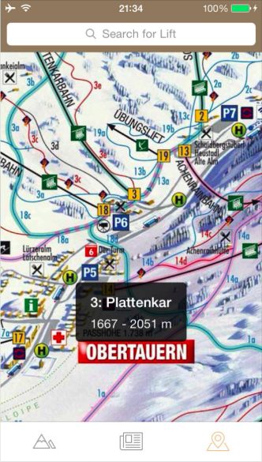This app provides language support for both German and English. This is an important feature for the app, as there are many English-speaking people and countries near Austria so the hill most likely gets many visitors that only speak one of those two languages. The multilingual feature also opens an entirely new market for the app and can therefore draw in more people to the ski resort

1. Simple and cool design

There are some animations incorporated into the design of the app that help it stand out when compared to other apps. For example, the interface changes depending on the current time of day; sunny when it is daytime and dark when it is night. It is clear to see that the developers of this app worked to keep the viewing area as un-cluttered as possible. This allows the user to sort through the provided data with no distractions. The page that the users can visit to see the photographs taken by other users is also organized in an uncluttered-manner where there are no words. Instead the pictures are displayed as thumbnails until the user taps one, and then it expands to fill the screen.

1. Easy to search and find of lift info

The app provides information about the ski lifts offered by the resort. When looking at the interactive map of the resort on the app, the app will show the real-time status of the lift, be it operation, closed, or under maintenance. The problem with this is that this is all that the app shows on its map besides the locations of the various runs. While this is a good feature to have, there is much more that the developers could do with this app to give the user more information about the status of the lift.

## Method 3:

The last IDEO method that we have chosen to perform is foreign correspondent. Every winter, lots of skiers and snowboarders from other countries come to the Alberta because ski hills in this province and country are world famous. However, there are many different ski hill systems and rules throughout different countries that are very different form our own that can confuse foreigners. They need an app which provides information of the Alberta ski hills that will be organized in detail and easy to access. Also, it will be possible to get more total users if we carefully consider foreign users and apply the functionality that they need. We can conduct this method in two ways. First, we will interview a friend from Norway regarding his experiences skiing in both Alberta and Norway, with a focus on the differences. We will also get experience of skiing at the resorts of South Korea and research about the process that Korean people usually do when they go skiing or snowboarding.

**- Interview questions for Norwegian –**

1. Where are you from?

From Norway.

1. How often do you go to ski?

It differs from time to time. About maybe 10 days per year. The winter season in Norway is November to March and ski hill opens at that time and close after March.

1. Do you ski or snowboard?

I just ski

1. What’s your level of skiing or snowboarding?

I guess I’m not a beginner. Just a little bit more than beginner. I have been skiing since I was a child.

1. have you ever skied or snowboard in other countries before?

No. I don’t think so.

1. Explain your usual trip to ski in detail. (from start to end)

First, I go in the internet and find a good deal that covers both a place to sleep and access to ski resort. Then I buy a ticket like a room or bus online. Then I take direct ski bus or just a general bus to go there. It usually takes 2 to 3 hours to get there from my home. Finally, I just ski all day long. I have ski gear, so I don’t need to rent anything. I usually eat lunch and dinner by cooking food that I brought from home in the cabin where I sleep. But when I go for one day trip I just bring my lunch from my home.

1. What are the problems that bother you when you go to ski? Anything inconvenient when skiing in Norway?

Sometimes transportation bothers me because it only leaves once a day, so I must wait all day long to get to ski hill or come back home. And price range of ticket is not that flexible. In Norway, I must buy whole or nothing to ski. There is no way to ski just 2 hours or short time. Oh, but there is one app that is very useful. It has snow alarm which tells you when the snow is good in ski hill and which resort is good.

**- Skiing process and system in South Korea -**

In South Korea, most of people search for a slope offering month and time on the most popular website called ‘Naver’ by computer or mobile devices. It shows all the 18 ski hill resorts in South Korea. South Korea is quite a small country so people can go any resort wherever they are. Moreover, there are lots of blogs that give reviews and more info about ski hills in detail. Then a user can find information of ski hills in homepage or blogs to compare among them and then pick the best one. Different from Canada, many young people in Korea have no cars so they usually check for existence of shuttle bus which covers most of the regions. Even the resorts can provide a free shuttle bus. Also, they consider the price of rental, lift, accommodation near the ski hill. Most of people rent gear and ski wear at the ski-hill or a nearby rental store. Usually there are lift and rental packages which give cheaper prices than renting the gear separately. There are three types of lift ticket, all day, afternoon, night, and dawn skiing. Lastly, they can make a reservation for room, rental, and shuttle bus if they don’t have a car.

After planning a ski trip, they usually go to ski-hill by shuttle bus early in the morning for a day trip if they don’t reserve a room. Each shuttle bus which is allocated by ski resorts have a fixed stop. Then after arriving in the ski hill, they rent gear and ski wear to put on. They go out of the locker room and wait for the lift to go up the hill. There are beginner’s slope, intermediate’s slope and expert’s slope which can go up by separate lifts. But in Korea most of slopes have short length, narrow width, and little bit bad condition of snow. Besides in peak season, there are so many people that in every ski-hill people must wait for lift for 1-2 hours and even though they go up they cannot speed up because of huge crowd. So, there are lot of snow patrol in the hill in case of accidents. Also, there are lot of classes for beginners and even for experts to learn skiing or snowboarding with many friends. These classes are offered by the resort. For food, there are many different accommodations on the hill for visitors and even a mid-mountain lodge on the hill. Most people just eat lunch and dinner there even though it is expensive.

We can find quite different points from Alberta ski hill. First, they have shuttle bus from everywhere because of few young who have a car. Second, they have a quite poor condition of ski hill to ride but have a lot of classes to learn and make friends. Lastly, they prefer to go skiing or snowboarding for one day rather than going for a long time.

## Summary:

We worked to find IDEO methods that were different enough form each other so that we could get a large range of responses and will then be able to build a diverse and powerful phone application. The survey gathered us information from many people. This provided us with information about the market for our app and the kinds of needs that we need to and should work to fulfill to have a viable product. Researching other applications already in the market has given us insight into specific features of apps that we had not considered and perhaps should consider when designing this app. This research also highlighted what “features” are best to be avoided, such as requiring a user create a profile to view information that they can get online without a profile. Many of the more useful apps have kept their interfaces free of distractions, while giving great functionality to the user while they are off the hill. We are looking to make an application that can be sued both on the hill and off the hill. Through these other apps, we learned that a very important part of making an application that is viable for use on a hill is to have large buttons and quick response times so that the user does not get annoyed with the application and can quickly resume skiing. Probably the most important lesson to take away from researching other applications is that the app should make the information that a user can get through Google easier to access. This is the bare minimum that we need to achieve if we want to have a market viable product, else people will simply go back to Google. The benefit of interviewing people from other cultures is getting a very different perspective on what we should be looking for in an application and the practices of people throughout the world. It is very important to do this with the app that we are developing because skiing is a very international sport and people from different cultures, speaking different languages, and having different needs will be going to foreign ski resorts. If we can accommodate and provide for these cultural differences, our app will fill a gap in the market.

# Task Descriptions:

## Task 1:

Tom is an intermediate skier who is learning the sport and wants to become better at it. Because of Toms previous experience skiing, he knows what sort of conditions will make for a good day of skiing. Tom has just downloaded our app and has no experience with it. When he opens the app, he would like to view information regarding different ski resorts near him and can quickly discover what the conditions are like at each resort. Tom knows about 1 resort that he can access and would like to be able to search specifically for that resort but is also very open to trying other resorts if they are close enough and have good conditions.

Tom opens the app and types in the search bar his favorite resort. Tom enters the individual page for the resort. Tom then marks the resort as a favorite and goes back the search page. Tom then enters his home city and sees the list of resorts within a 400Km radius of his city. Tom then looks at the snow fall over the past day for each new resort and selects the top 3, marking them as favorites as he did his favorite resort. Tom then returns to the search page, opens the menu bar on the side, and selects the menu item shown as favorites. Tom then looks at the information page of each individual resort and compares the recent snowfall, travel distance, prices, and weather forecast for each location. Tom then closes the app.

## Task 2:

Sarah is an expert skier who skis internationally. Sarah has become very familiar with our application over the past several years. Sarah has an extensive list of favorite resorts and needs to be able to compare the conditions between each of the resorts very quickly. The most important things for Sarah when planning a ski trip outside of her home country is the weather forecasts, the base snow pack compared to the snow base at the current date last year, and the availability of hotels within 10Km of the ski hill for easy access.

Sarah opens the app and navigates to her favorites page. From here, she scrolls through her list of favorite mountains. She selects all the mountains that have been snowed on in the last day and uses the compare feature to see the statistics of all the resorts compared side by side. She finds a resort that looks like a promising venture and navigates to its individual page. She then finds the accommodations tab and sees several links to hotels at and near the resort. After following the links, she finds that none of the hotels will do and returns from the resorts individual page to the comparison page. She visits the next hills individual page and follows its links to nearby hotels. Sarah finds a hotel that will do and closes the app.

## Task 3:

         Sira is a tourist from South Korea currently lives in hotel in Calgary for 3 days with her friends. She and her friends wants to go snowboarding in Banff but they don’t have any gears to do. They already choose the ski hill to go, so they want to check for the rental place. They know renting gears in Calgary is cheaper than near ski hill. Also, they are going to rent a car to go there for a day trip.

         Sira and her friends are going to search in the app and change to Korean language to see more comfortable. They find the information about ski gears and car rental in Calgary. And they pick the cheapest and nearest place to rent a car and gears.

         In the ski hill, one of her friend is hurt in the middle of the slope. So, she finds ski hill information center number in the emergency section, and ask for help. After a few minutes, snow patrol come and get her friend to the nearest hospital.

## Task 4:

Benjamin is an exchange student from Norway and he is in intermediate level of skiing. He is expecting so much to ski in Banff, so he tries to find which ski hill is the best in Banff. He thinks important to check price of lifts and accessibility.

There is information about ski hills which place is best to go by bus and has cheapest price to

ski. So, he considers the price of a bus ticket and lifts.

He is planning to go for 3 days, so he also wants to find a good place to sleep near ski hill which provides kitchen. He will buy some foods that he’ll cook for breakfast, lunch and dinner, so he checks for grocery stores near the accommodation at the map.

## Task 5:

Patrick is an expert skier and snowboarder and wants to check information about a resort that he has not visited in a year. He wants to go skiing and already has most of the gear but must buy a new helmet. He plans to go sometime next weekend during Christmas with a group of friends.

He browses the list of resorts and searches for Sunshine village. He checks if the resort has any new hills to offer. He finds new hills and checks the difficulty of these hills. He checks the snow quality of the hills to see if it is freshly powdered which is the most preferable. He checks the resort shop to see if he can buy a helmet. He checks the resort rentals to see if it cheaper to rent a helmet several times. He checks the prices of the ski lifts tickets see if there are any holiday deals.

Patrick wants to make sure that the resort has everything for a weekend stay. He checks the food services of the resort. He checks the emergency services of the resort to see if there is an emergency number he can call. Finally, he checks if there are any nearby cabins to rent for his group of friends.

## Task 6:

Raza is a university student who is also a beginner. He heard from a friend that a resort named Panorama Mountain is an excellent place to go for beginners. He does not want to spend more money than what his budget allows and will stay for just the morning at the resort. He borrows the following skiing gear from a friend:

* Skis,
* Ski poles
* Goggles
* Helmet

To confirm that Panorama Mountain is a good place to go, he browses the list of resorts and searches for Panorama Mountain specifically. He looks at the overall rating of the resort. For more insight, he checks the user reviews of the resort. Next he must figure out if the resort can fit his budget so he checks the resort rentals. He looks at skiing boot sizes because his friends size does not fit him. After confirming that the resort has his boot size, he looks at the prices of the ski lifts. Finally, he looks at the location of the resort and the trail map to see if it is close to his home.

## Task 7:

Terry is a member of the ski patrol at his local ski resort. He has just gotten back to the ski patrols main base when his phone begins to vibrate. He checks his phone and sees a notification reporting that there is an injured skier on a nearby run! Terry then accesses the report by taping on the notification. He can see on the report that the skier was skiing with 1 other person who has begun to ski to the nearest chair lift to find help. Included in the report is a description of this second skier. Terry goes to the lift near his base. Eventually the second skier shows up and reports the injury, terry marks the report as in progress and travels to meet the injured person. When Terry returns to the ski patrol base, he marks the report as completed and closes the app.

## Task 8:

Sam is a manager at a hotel near a ski resort. Sam’s hotel is having a weekend special on rooms for 4 or more people and needs to advertise this. Sam has advertised in other locations but wants to do more so he opens our app and finds the ski resort hear him. Sam then navigates over to the accommodations page, finds his hotel in the list, opens the page for his hotel, and posts an image describing the weekend deal with all important information. Terry then closes the app.

# Appendix:

